CPSC 3300 - Exam 1 Sample Questions

1. Matching -- technology/performance terms. Write the correct term from the

list into each blank. (1 pt. each)

datapath Dennard scaling throughput supercomputer

CPU time Moore’s law bit workload

clock frequency CPI byte Whetstone

a. ___Moore’s law___ the observation that the number of transistors in a dense

integrated circuit doubles approximately every two years

b. __supercomputer__ a computer with the highest performance and cost

c. _______bit_______ a single binary digit (1 or 0)

d. _clock frequency_ 1/clock cycle time. Also number of clocks per second.

e. ___CPU time______ time spent processing a given job

f. ____throughput___ measure of work done per unit time

2. Give the power of 10 associated with these prefixes. (1 pt. each)

milli _10^-3__ mega _10^6__

exa _10^18__ micro _10^-6__

3. For the following workload and cycle values, find the average CPI. (4 pts.)

type | freq cycles

-------+-------------- CPI = __________1.5________________

alu | 0.70 1

ld/st | 0.20 2

branch | 0.10 4

4. Given the workload and cycle values from question 3 with an instruction count of

40 million and a clock frequency of 2 GHz, find the execution time. (8 pts.)

Execution/CPU Time = CPI x IC x 1/clock rate

= (1.5) x (40,000,000) x (1/(2 x 10^9))

= 0.03 seconds

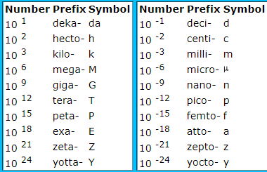

5. Consider the execution times of two different programs in a benchmark suite on

three different computers:

|  |  |  |  |
| --- | --- | --- | --- |
|  | Computer A | Computer B | Computer C |
| Program 1 | 10 | 12 | 16 |
| Program 2 | 10 | 3 | 4 |

Calculate the normalized execution times of the benchmark suite on the three

computers (using geometric mean) with respect to Computer A: (8 pts.)

|  |  |  |
| --- | --- | --- |
| Normalized to A | | |
| Computer A | Computer B | Computer C |
| 1 | 1.2 | 1.6 |
| 1 | 0.3 | 0.4 |

Sqrt(1 x 1) sqrt(1.2 x 0.3) sqrt(1.6 x 0.4)

A: 1 B: 0.6 C: 0.8

6. Give a circuit implementation for an XOR circuit using AND, OR, and NOT

gates. (8 pts.)

a b | XOR

-------+-------------

0 0 | 0

0 1 | 1

1 0 | 1

1 1 | 0

7. Consider A + B*C = (A+B)*(A+C). Show by truth table that this is true. (10 pts.)

|  |  |  |  |  |  |  |  |
| --- | --- | --- | --- | --- | --- | --- | --- |
| A | B | C | (B*C) | **A + B*C** | **(A+B)*(A+C)** | A+B | A+C |
| 0 | 0 | 0 | 0 | **0** | **0** | 0 | 0 |
| 0 | 0 | 1 | 0 | **0** | **0** | 0 | 1 |
| 0 | 1 | 0 | 0 | **0** | **0** | 1 | 0 |
| 1 | 0 | 0 | 0 | **1** | **1** | 1 | 1 |
| 0 | 1 | 1 | 1 | **1** | **1** | 1 | 1 |
| 1 | 1 | 0 | 0 | **1** | **1** | 1 | 1 |
| 1 | 1 | 1 | 1 | **1** | **1** | 1 | 1 |
| 1 | 0 | 1 | 0 | **1** | **1** | 1 | 1 |

8. For the Boolean function O1 and O2, as given in the following truth table:

(6 pts. each)

|  |  |  |  |  |
| --- | --- | --- | --- | --- |
| **Input** | | | **Output** | |
| **x** | **y** | **z** | **O1** | **O2** |
| 0 | 0 | 0 | 1 | 0 |
| 0 | 0 | 1 | 0 | 0 |
| 0 | 1 | 0 | 0 | 1 |
| 0 | 1 | 1 | 1 | 1 |
| 1 | 0 | 0 | 0 | 1 |
| 1 | 0 | 1 | 1 | 0 |
| 1 | 1 | 0 | 1 | 0 |
| 1 | 1 | 1 | 0 | 1 |

(a) List the minterms for a three-variable function with variables x, y, and z.

(‘x*’y*’z), (‘x*’y*z), (‘x*y*’z), (‘x*y*z), (x*’y*’z), (x*’y*z), (x*y*’z), (x*y*z)

(b) Express O1 and O2 in sum-of-product algebraic form.

O1 = (‘x*’y*’z) + (‘x*y*z) + (x*’y*z) + (x*y*’z)

O2 = (‘x*y*’z) + (‘x*y*z) + (x*’y*’z) + (x*y*z)

9. You are provided with NOR gates only. (4 pts. each)

(a) draw the circuit to implement the AND function

(b) draw the circuit to implement the OR function

10. Prove the identity of each of the following Boolean equations, using algebraic

manipulation: (4 pts. each)

(a) ~(A * B) * (~A + B) * (~B + B) = ~A

(b) (A * B) + (B * C) * (B + C) = B * (A + C)

11. In a carry-lookahead adder two signals are created for each bit position -

P: “(carry) propagate” and G: “(carry) generate” which are used to determine

the carry bit for the next (higher) bit position. (6 pts. each)

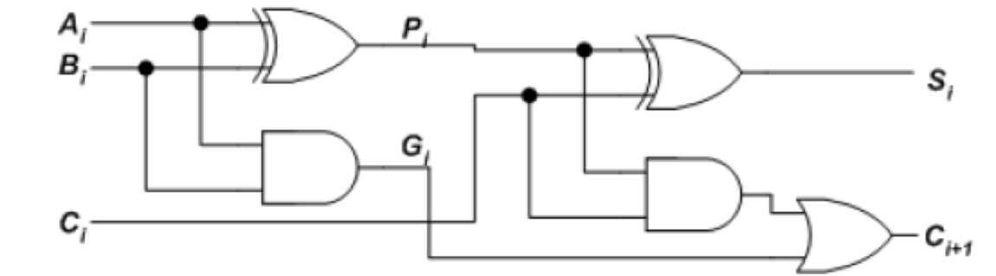

(a) Given the formula for Ci+1 (carry bit for next position) is:

Ci+1 = Gi + (Pi * Ci), write out the formulas for C1, C2 and C3 in terms

of C0, P0, G0, P1, G1, P2 and G2.

(b) Draw the circuit diagram of a 3-bit carry-lookahead unit with inputs

C0, P0, G0, P1, G1, P2 and G2 and outputs C1, C2 and C3.

12. Consider a mod-4 counter with input R. When R=0 the counter will increment in a

loop from 00 to 11, e.g. 00->01->10->11->00... When R=1 the counter is reset

to 00. (4 pts. each)

(a) Draw the state transition diagram. Label the up transitions with '0' and

the reset transitions with '1'.

(b) Give the state table using S1(t) and S0(t) for current state.

(c) Give the logic expressions for Q1(t+1) and Q0(t+1).